**BAHRIA UNIVERSITY (KARACHI CAMPUS**)

**Introduction To Software Engineering (SEN- 120)**

**Assignment 03**

**Spring 2023**

**Class: BSE 2B Shift: Morning**

**Course Instructor: Engr. Mobeen Nazar Due Date: 1 June 2023**

**Assignment Date: 24 May 2023 Marks: 07 Points**

**Student Name: ABDULLAH Enrollment #: 02-131222-099**



Question: Apply UML diagrams for designing grocery store management as mentioned in the given scenario. **(CLO 03)**

**SCENARIO:**

Assume you are contacting a grocery store client who runs a grocery store chain in the city. This client wants to design a piece of software to handle the day-to-day operations of the business. You have asked for information about how the business is run and received this description.

“We own several stores in the city and need to keep track of availability of stock items in each store. We have two types of customers; one is an online customer, who can book an order through this software. This order may take all the information regarding the online customer’s details and items that need to be purchased. Once the order has been finalized by the customer then the payment can be made through cash on delivery and credit card methods. The other type of customer is a walk-in-customer which selects all the items in a store and then pays at the counter. These two customers can also become registered customers of this store by getting a membership card. Only registered customers can avail discount offers on special occasions or specific amount of shopping from the store.”

Create:

1. Class Diagram
2. Sequence Diagram (Any two activities).

Solution:

Class Diagram:

Sequence Diagram:

1. Online customer places an order and pays by credit card:

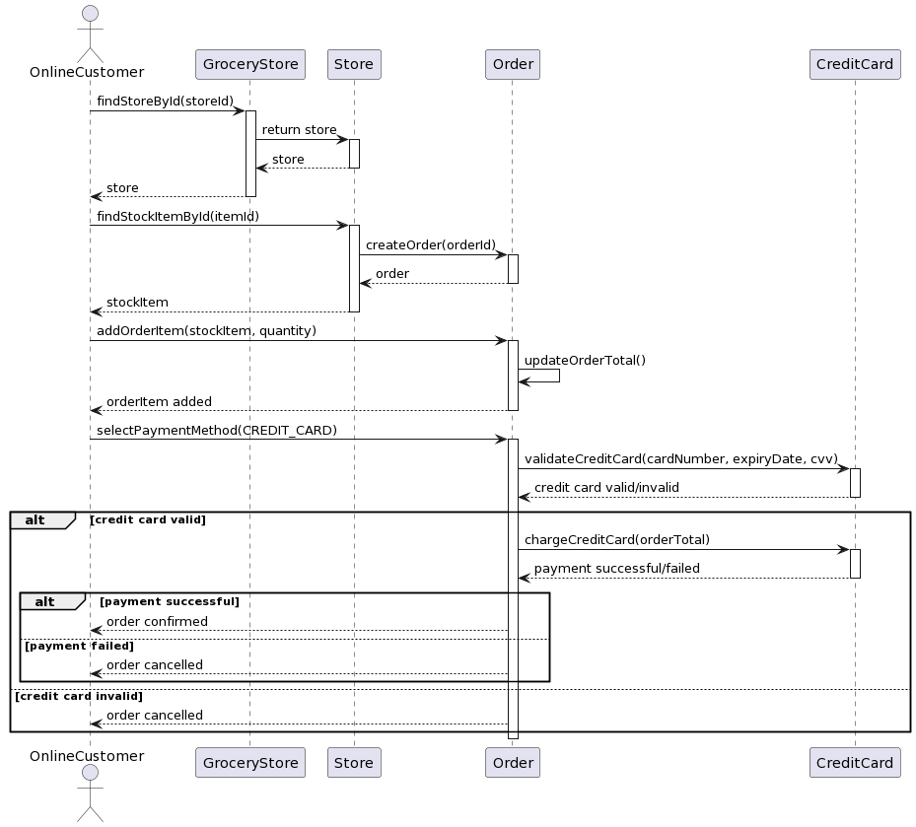

1. Walk-in customers buy items and gets a membership card:

